bptour - Introduce a Korean girl group

### Site title:

BPTOUR

### Need:

Introduce a south Korean girl group who is a member of the group. The website basic is an advertisement of the group which is let people know the rope of the group to like it or interesting them.

### Rationale of focus:

The website tries to use more visual communication let user have good immersive experience when they are reading.

### Main elements outline:

|  |  |
| --- | --- |
| Headers | It may contain some heading element. |
| Nav | Represents a section of a page whose purpose is to provide navigations links. |
| Table | Including multiply <tr>, <th> & <td> element |
| Div id: | It is generic container for flow content, no effect until style in some way using CSS. May only use the same id once per page. |
| Div class: | Use CSS to style each chuck with one rule. |

### Content:

The web page will be including:

* Bptour
* Bp_view
* Bp_thing

First page is photo of the group member, the web would like to give a visual communication with the user. Then when click the photo will be go to the second page which is including of that introduce everyone in the group. When user go to the last page will be see the water pull of their pictures.

### Target audience:

The fans of the group, and people who like a pop music.

### Design considerations:

Actually, visual communication was not a good way to excitation of people who are not interesting of that. This is kind of like to see someone for the first time, how to arouse curiosity of people it is most impotent things. But, still a good experiment.

Keep the design motif as same in each page, and relating each page consider the user mine will be good things for the website.

TEST RESULT:

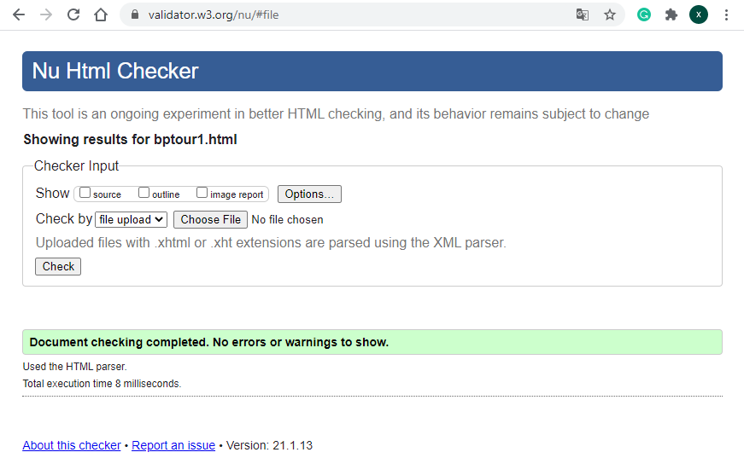

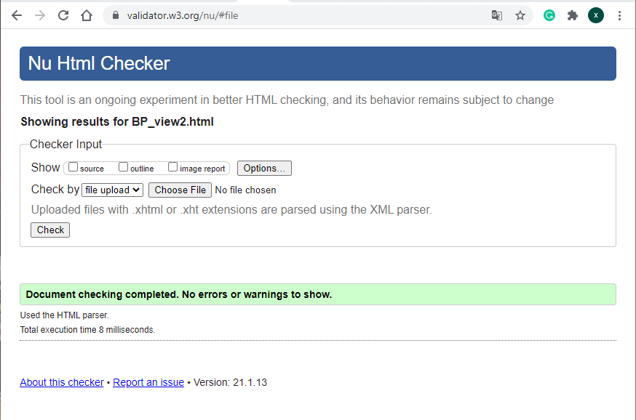

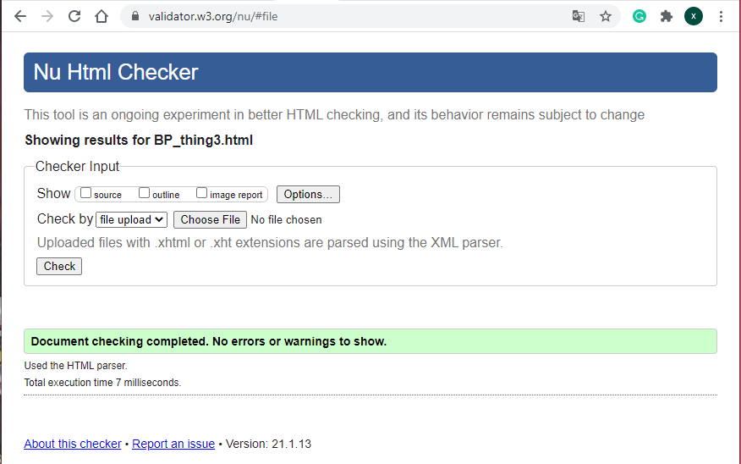

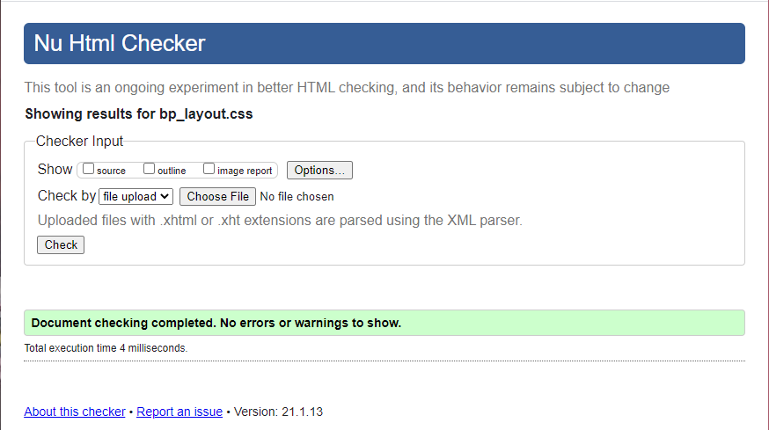

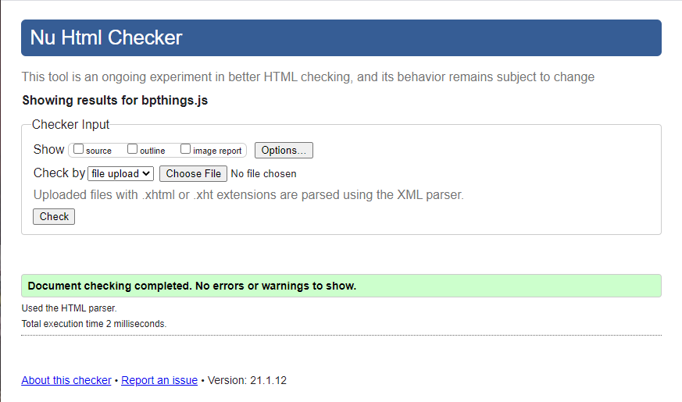

# Works Cited

(n.d.). Retrieved from https://www.pinterest.nz/pin/672866000554670695/

(n.d.). Retrieved from https://www.reddit.com/r/BlackPink/comments/9xjwiu/blackpink_in_your_area_japanese_album_release/

(n.d.). Retrieved from https://www.instagram.com/blackpinkofficial/

(n.d.). Retrieved from https://www.w3schools.com/tags/tag_abbr.asp

(n.d.). Retrieved from https://www.w3schools.com/